# LAB # 6

**Object: To Practice resistor color coding. Equipment:**

* + Resistors
  + Multimeter
  + Color Coding chart

**Theory**

Resistance is the property of a material to oppose the flow of current. The element that opposes the flow of current is called a resistor. It is represented by “R”. The unit of resistance is ohms (Ω).

1 Kilo ohm= 1000 ohms

1 Mega ohm = 1000 000 ohms

**Procedure**

**Resistance With Multimeter:**

1. **Power Off**: Ensure the circuit or device containing the resistor is powered off. This prevents any interference or damage to the multimeter.
2. **Select Resistance Mode**: Turn on the multimeter and set the dial or switch to the resistance (Ω) mode. On many DMMs, this is indicated by the Ω symbol.
3. **Range Selection**: Choose an appropriate range for the resistance you expect the resistor to have. If you're unsure of the resistor's value, start with the highest range and work your way down until you get a more precise reading.
4. **Probe Connection**: Identify the two test leads (probes) of the multimeter. The black probe typically connects to the COM (common) terminal, and the red probe connects to the terminal marked with Ω or the one used for resistance measurements.
5. **Probe Placement**: Place the probes across the resistor whose resistance you want to measure. Ensure that each probe's tip makes good contact with each lead of the resistor. The multimeter will then measure the resistance between these two points.
6. **Reading**: Read the resistance value displayed on the digital screen of the multimeter. Digital multimeters typically display readings directly on the screen, making it easy to read.
7. **Recording the Value**: Record or note down the resistance value measured by the multimeter in the observation table.

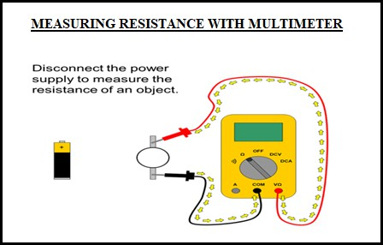

**Remember while measuring resistance**

* + You can only test resistance when the device you're testing is not powered.
  + You can only test a resistor before it has been soldered/inserted into a circuit. If you measure it in the circuit, you will also be measuring everything connected to it.
  + Resistance is non-directional; you can switch probes and the reading will be the same.

**OBSERVATIONS**

|  |  |  |  |  |
| --- | --- | --- | --- | --- |
| **S.NO** | **COLOR BANDS** | **CHART** | **MULTIMETER** | **DIFFERENCE** |
| **1** |  |  |  |  |
| **2** |  |  |  |  |
| **3** |  |  |  |  |

**Resistance with color coding chart:**

The resistance color code chart is used to determine the resistance value of a resistor based on the colors of the bands painted on the resistor. Each color represents a number, a multiplier, and sometimes a tolerance value.

**Resistance Color Coding Chart**

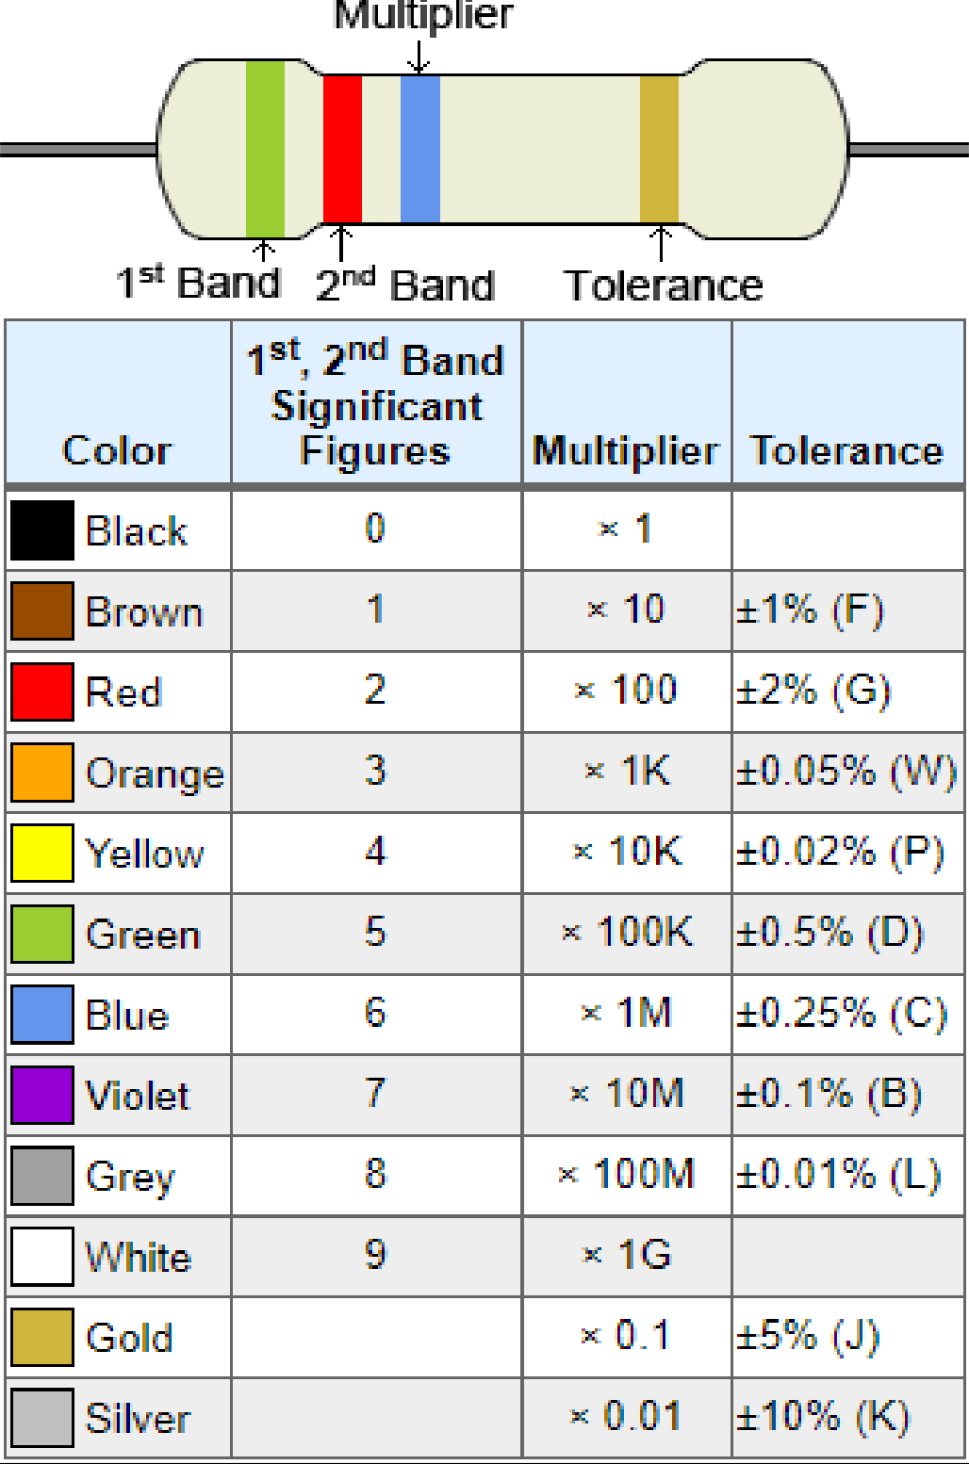

**POST LAB:**

1. How multimeter is connected for measuring resistance?
2. Which band indicates the multiplier?
3. Which band indicates the tolerance of a resistor?
4. What will be the tolerance if 4th color band is silver?